Explanatory note
Sculpture artwork such as the Monument to the heroes of the Alaska-Siberia Air Route is planned to be installed in the park on 15 and 16 Aerovokzalnaya Street in Sovetsky district in Krasnoyarsk. The park is located on the crossing of Berezina and Aerovokzalnaya streets, in the south-west of the district. It is integrated into the green pedestrian route, connecting the Park of the 400th Anniversary of Krasnoyarsk through Vesny Street. It also has a perfect vehicle accessibility and connection to the main streets of the city (Partizana Zheleznyaka Street and Shakhterov Street).
Vzlyotka and the Novy Centre district and such large city venues as equestrian centre, Branch of the Saint Petersburg State University of Civil Aviation, the Krasnoyarsk State Medical University, and Regional Clinical Hospital are all in the close proximity to each other.
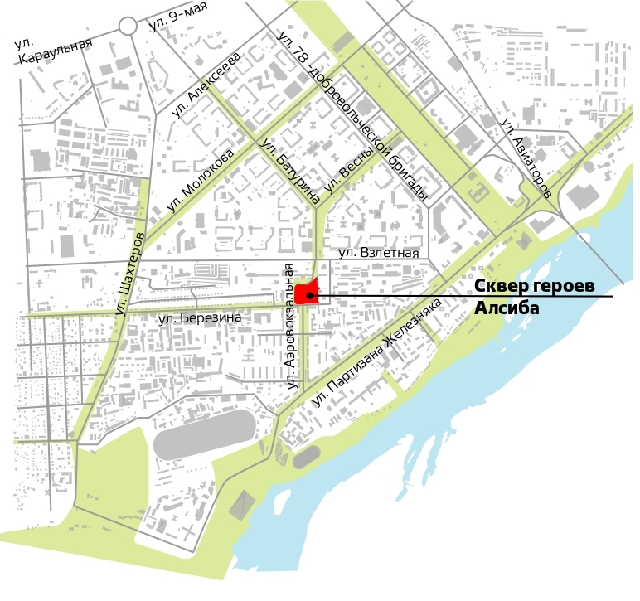
The Krasnoyarsk City Administration will accomplish works on urban land improvement in the park in 2021.
The project includes such recreation areas as pedestrian paths and other walking routes, kids’ playground, lounge area, outdoor activities area, and green area. In addition, hard landscaping and lighting will be installed in the park.
The sidewalk area is to be paved with a cobblestone of small-piece elements, the pedestrian area has a cobblestone pavement as well, and the monument area is designed with large-sized paving stones.
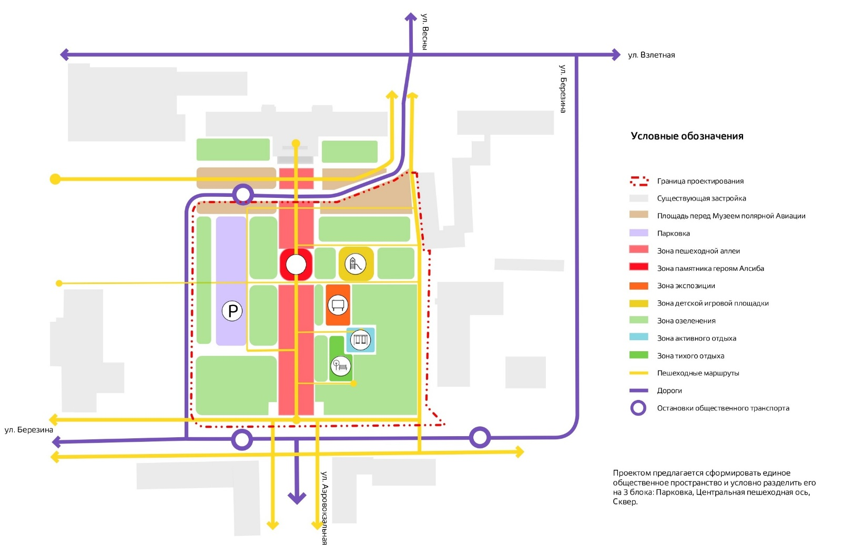

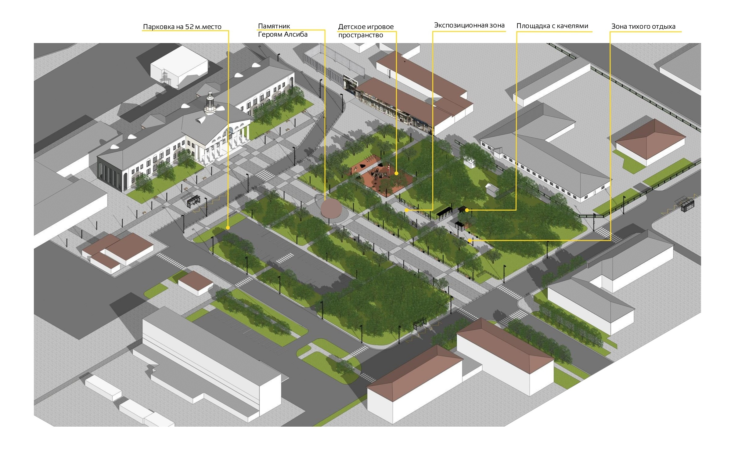

The Monument to the heroes of the Alaska-Siberia Air Route is planned to be installed on the central pedestrian walkway in front of Aerovokzal building (former airport terminal). The building was accepted for state protection as an object of cultural heritage of regional significance “Aerovokzal, 1954” by order of the Service for State Protection of Cultural Heritage Sites of the Krasnoyarsk region.
The location of the future sculpture is available on Google maps via the link https://www.google.ru/maps/@56.0323936,92.9074221,3a,75y,357.54h,92.28t/data=!3m6!1e1!3m4!1stwebfQz1WnZiV4ashsdXSA!2e0!7i13312!8i6656.
Aerovokzal (former airport terminal) is a large two-storey stone rectangular building with a risalit on the south side and porticos and porches on the north and south sides. The belvedere in a shape of octagonal prism rises above the central part of the building. The podium with colonnades and porches are located on the western and eastern sides.
The building was constructed in 1954. Being a great example of Neoclassicism it represents the interpretation of classical architectural forms to enhance the typological facade.
The Aerovokzal building was associated with the aviation development in the Krasnoyarsk region. Many historical figures such as Fidel Castro, Yuri Gagarin, Walter Ulbricht, Leonid Brezhnev and Konstantin Chernenko visited the airport over the years.

Project description:
The schematic design of the Monument to the heroes of the Alaska-Siberia Air Route should stick to its meaning when it is observed from the side of the former airport terminal, Polet Hotel and Aerovokzalnaya Street. The project should be perceived from close and distant spots. Images, texts, names, titles should be visible if they are available in the project. The project should be made of durable, tamper resistant materials and using proven technologies. It is recommended to take into account the methodology for determining the cost of creating works of fine art in the territory of the Russian Federation, GDC 81-42.2008, and dd. 08.04.2008, No. VB-1381/02-110.09.2020 when carrying out the monument estimate of cost.

